## Reports/Inventory Reports/CII Reports/View Drug Order

Request:

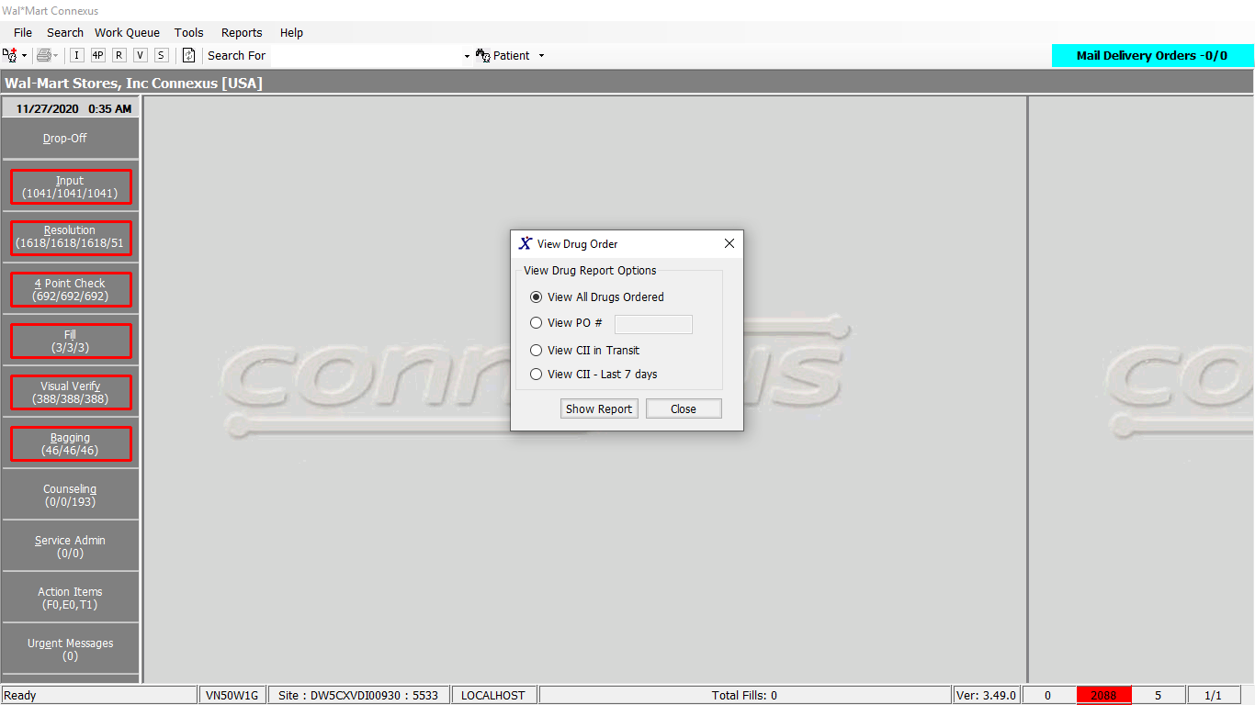

Response:

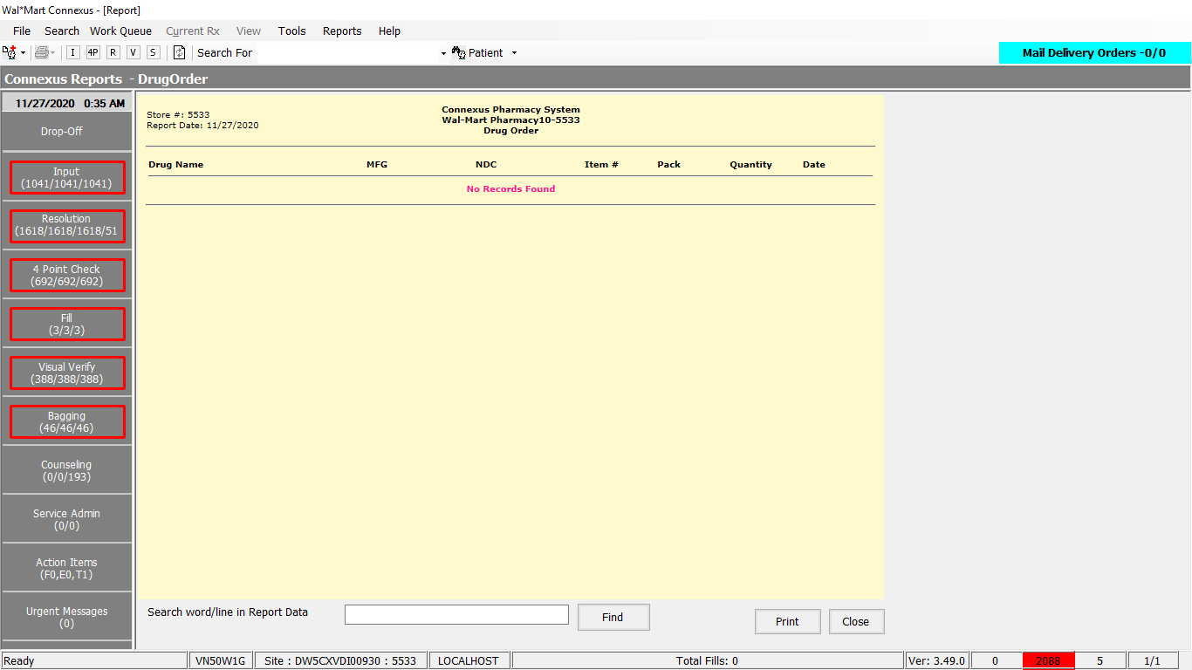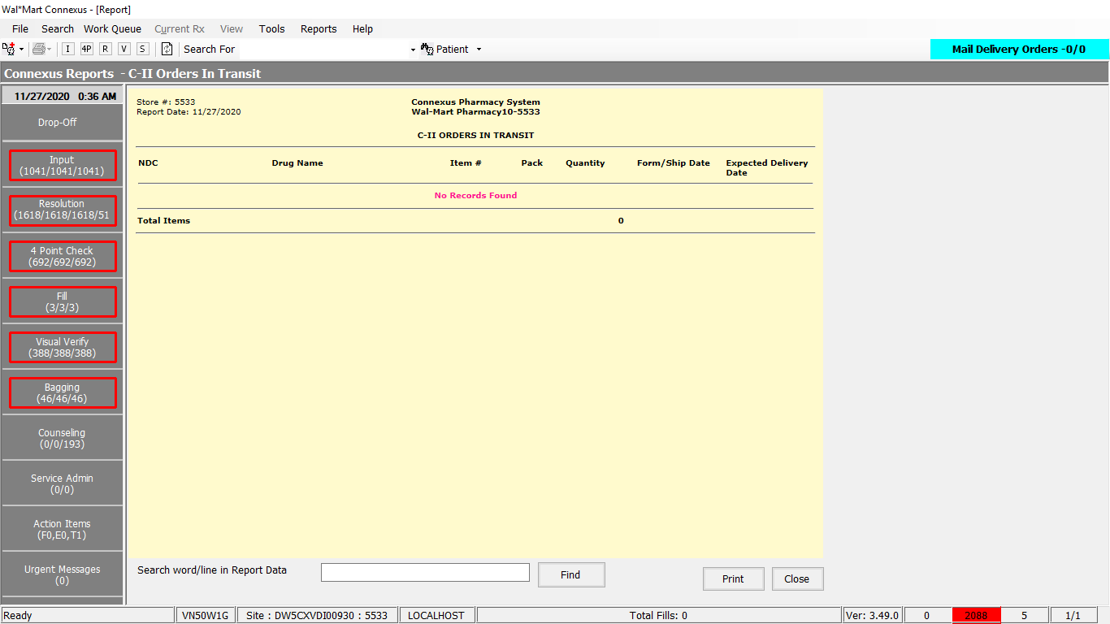

Query:

1. Friend Const GetDrugOrdersSelect_QA41 As String = "SELECT pi.ndc_nbr, pp.short_name, pir.supplier_ref_nbr,pi.inner_pack_qty, (dpl.system_order_qty + dpl.manual_order_qty) order_qty, dp.order_date,pc.phm_co_name_abbr, dp.drug_po_id po_nbr, lab.labeler_short_name FROM drug_po dp, drug_po_line dpl,pharmacy_item pi, pharmacy_product pp, phm_item_repl pir, rx21c:phm_company pc, labeler_txt lab WHERE dpl.drug_po_id = dp.drug_po_id AND dpl.mds_fam_id = pi.mds_fam_id AND pi.product_mds_fam_id = pp.product_mds_fam_id AND pc.phm_co_id = pir.phm_co_id AND pir.mds_fam_id = pi.mds_fam_id AND pir.pri_supplier_ind = 'Y' AND pi.labeler_id = lab.labeler_id AND dpl.status_code = 23010 "

2.

Friend Const GetDrugOrdersSelect As String = "Select pi.ndc_nbr, pp.short_name, pir.supplier_ref_nbr, pi.inner_pack_qty, pirh.order_qty, pirh.order_date, pc.phm_co_name_abbr, pirh.po_nbr, lab.labeler_short_name FROM phm_item_repl_hist pirh, pharmacy_item pi, pharmacy_product pp, phm_item_repl pir, rx21c:phm_company pc, labeler_txt lab WHERE pirh.mds_fam_id = pi.mds_fam_id AND pi.product_mds_fam_id = pp.product_mds_fam_id AND pc.phm_co_id = pir.phm_co_id AND pir.mds_fam_id = pi.mds_fam_id AND pir.pri_supplier_ind = 'Y' AND pi.labeler_id = lab.labeler_id AND pirh.receive_date IS NULL "

DAL:

Public Function GetDrugOrders(ByVal siteId As Integer,

ByVal drugOrder As Integer, ByVal poText As String) _

As List(Of GetDrugOrdersInfoBE) Implements IReportDAL.GetDrugOrders

Using (New Tracer(ConnexusCommonConstants.ConnexusTracer))

Dim sqlString As New StringBuilder

Dim getDrugOrdersInfoBEList As New List(Of GetDrugOrdersInfoBE)

' if it's CII VIEW ORDER IN TRANSIT

If drugOrder = ServicesCommonConstants.ReportTypeC2Transit Then

GetC2OrdersInTransit(siteId)

Else

If CacheWrapperDal.GetCountryCode(siteId) = ServicesCommonConstants.CanadaCC AndAlso

drugOrder <> ServicesCommonConstants.ReportTypeC2Last7Days Then

sqlString.Append(ReportQueries.GetDrugOrdersSelect_QA41)

Dim po As Integer = 0

If Integer.TryParse(poText, po) AndAlso po > 0 Then

sqlString.Append(" AND dp.drug_po_id =" & poText)

Else

sqlString.Append(" AND dp.order_status_code =" & DrgOrdStat.Sent)

End If

sqlString.Append(" ORDER BY pp.short_name")

Else

sqlString.Append(ReportQueries.GetDrugOrdersSelect)

If Not poText Is Nothing AndAlso poText.Trim.Length > 0 Then _

sqlString.Append(" AND pirh.po_nbr='" & poText & "'")

If drugOrder = ServicesCommonConstants.ReportTypeC2Last7Days Then

sqlString.Append(" AND pp.drug_control_code= 2300 ")

sqlString.Append(" AND (pirh.order_date >= (TODAY-7) AND pirh.order_date <=TODAY)")

End If

sqlString.Append(" ORDER BY short_name")

End If

Dim dataReader As IDataReader = ExecuteReader(DatabaseEnum.Pharmacy_Offering,

siteId, sqlString.ToString)

Dim getDrugOrdersInfoBE As GetDrugOrdersInfoBE

While dataReader.Read

getDrugOrdersInfoBE = New GetDrugOrdersInfoBE

If Not dataReader.IsDBNull(dataReader.GetOrdinal("inner_pack_qty")) Then

getDrugOrdersInfoBE.InnerPackQty = CInt(dataReader("inner_pack_qty"))

End If

If Not dataReader.IsDBNull(dataReader.GetOrdinal("labeler_short_name")) Then

getDrugOrdersInfoBE.LabelerShortName = CStr(dataReader("labeler_short_name")).Trim

End If

If Not dataReader.IsDBNull(dataReader.GetOrdinal("ndc_nbr")) Then

getDrugOrdersInfoBE.NdcNbr = CStr(dataReader("ndc_nbr")).Trim

End If

If Not dataReader.IsDBNull(dataReader.GetOrdinal("order_date")) Then

getDrugOrdersInfoBE.OrderDate = CDate(dataReader("order_date"))

End If

If Not dataReader.IsDBNull(dataReader.GetOrdinal("order_qty")) Then

getDrugOrdersInfoBE.OrderQty = CInt(dataReader("order_qty"))

End If

If Not dataReader.IsDBNull(dataReader.GetOrdinal("phm_co_name_abbr")) Then

getDrugOrdersInfoBE.PhmCoNameAbbr = CStr(dataReader("phm_co_name_abbr")).Trim

End If

If Not dataReader.IsDBNull(dataReader.GetOrdinal("po_nbr")) Then

getDrugOrdersInfoBE.PoNbr = CInt(dataReader("po_nbr"))

End If

If Not dataReader.IsDBNull(dataReader.GetOrdinal("short_name")) Then

getDrugOrdersInfoBE.ShortName = CStr(dataReader("short_name")).Trim

End If

If Not dataReader.IsDBNull(dataReader.GetOrdinal("supplier_ref_nbr")) Then

getDrugOrdersInfoBE.SupplierRefNbr = CInt(dataReader("supplier_ref_nbr"))

End If

'Add the BE object to the BEList

getDrugOrdersInfoBEList.Add(getDrugOrdersInfoBE)

End While

End If

If getDrugOrdersInfoBEList.Count > 0 Then

Return getDrugOrdersInfoBEList

Else

Return Nothing

End If

End Using

End Function